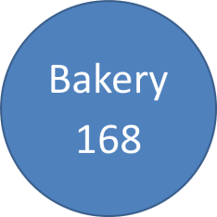
BAKERY 168

LEAVE FORM
The letter must be submitted to the Head of Department or the Head of Department
Legal Information

Employee’s name: Role
Department:
Chief in charge:
Absence Reuest ៖
Annual Leave Sick Leave Prenancy Leave

Others
DD MM YY
DD MM YY

Period: .........Days From / / Until / / Back to Work
DD MM YY
on / / .
Reason:

(You must complete this form and submit it to the Manager or Supervisor at least two days prior to the your leave, unless there is an accident, illness or emergency. For more information, contact the Human Resources Manager)

Requester Signature and Name
Date

Manager Review

Approve
Not Aprrove, Because:

Signature and Manager's Name
Date

(The Supervisor or Division Manager will hand the document over to the HR manager after signing)

